

DAFFODIL INTERNATIONAL UNIVERSITY
DEPARTMENT OF COMPUTER SCIENCE AND ENGINEERING
FYDP (Phase-I) Evaluation Report
reporting period- spring 2026
Project Identification:
I. Project Title | AI-Based Early Detection of Depression from Twitter Data
II. Group Members | Name: Most. Sumaiya Akter Sithi. Student ID: 0242220005101915
III. Supervisor | Name: Dr. Arif Mahmud  Designation: Associate Professor & Associate Head
IV. Co-Supervisor | Name: Mr. Md. Sadekur Rahman  Designation: Assistant Professor
V. Submission Date: | 13-04-2026
VI. Certificate: | “This is to certify that the final year design project work until Phase-I evaluation held on ___________________, titled as stated in Sec. I, executed by the students’ group mentioned in Sec. II, have been found satisfactory and every section of this report is reflecting the same.” |   (Signature of Supervisor & date)

Project Insights
Thematic Area(s):  [Just click the check box] | Artificial Intelligence and Machine Learning | ☒
 | Deep Learning | ☒
 | Health Informatics | ☒
 | Cybersecurity | ☐
 | Software Engineering and Development | ☐
 | Blockchain Technology | ☐
 | Internet of Things (IoT) | ☐
 | Computer Networks | ☐
 | Computer Vision | ☐
 | Natural Language Processing (NLP) | ☒
 | Robotics | ☐
 | Game Development | ☐
 | Cloud Computing | ☐
 | Image Processing | ☐
 | Others (please specify):
Software packages, tools, and programming languages | Kaggle dataset source, Python, Google Colab, Pandas, NumPy, Scikit-learn, TensorFlow/Keras, Matplotlib, Seaborn, NLTK, and Colab notebooks.

CO Description for FYDP-Phase-I
CO | CO Descriptions | PO
CO4 | Perform economic evaluation, cost estimation, and apply suitable project management procedures throughout the FYDP lifecycle in the context of developing the “AI-Based Early Detection of Depression from Twitter Data” project. | PO11
CO6 | Select and apply appropriate methodologies, resources, and contemporary engineering/IT tools for prediction, modeling, and solving complex engineering processes for the “AI-Based Early Detection of Depression from Twitter Data” project. | PO5
CO7 | Assess societal, health, safety, legal, and cultural issues and responsibilities in professional engineering practice related to the FYDP problem. | PO6
CO10 | Operate effectively as an individual and as a member/leader in multidisciplinary teams during FYDP. | PO9

- Project Overview

  - Introduction
The project aims to develop an artificial intelligence based system for the early detection of depression-related signals from Twitter data. The main objective of Phase-I was to build a complete baseline pipeline starting from data collection and preprocessing to model development and preliminary evaluation. The system is designed as a depression-related text classification framework rather than a clinical diagnostic tool. It analyzes linguistic patterns in social media posts and predicts whether a text is likely to indicate depression-related content or not. Furthermore, the project investigates how different computational approaches perform on noisy and short social media texts, which are often challenging for automated classification. By comparing multiple models under a consistent preprocessing and evaluation pipeline, this study provides an initial research foundation for selecting the most suitable approach for the final phase of the thesis.

  - Background Study
Depression is a major public health concern, and social media platforms provide large volumes of user-generated text that may reflect mood, stress, hopelessness, or emotional distress. Recent studies from 2022 onward show that depression detection from social media has increasingly shifted toward stronger comparative pipelines, transformer-based models, explainable systems, and deeper contextual representations. At the same time, researchers continue to report key limitations such as noisy labels, short-text ambiguity, platform-specific bias, and weak generalization across datasets [1]-[6].
Ref.  No. | Author(s) & Year | Method / Model Used | Dataset / Platform | Key Contribution | Limitations / Remarks
[1] | J. Cha et al. (2022) | Lexicon-based + deep learning analysis | Twitter + university community | Explored early-stage depression detection using social-media language signals. | Useful for signal analysis, but context sensitivity remains limited.
[2] | R. Poświata and M. Perełkiewicz (2022) | RoBERTa, XLNet, DepRoBERTa ensemble | LT-EDI depression shared-task data. | Showed transformer-based models are strong for depression text classification. | Task-specific dataset; multiclass setting differs from binary tweet classification.
[3] | M. A. Al-Garadi et al. (2023) | Systematic review + classification framework | 50 social-media depression studies | Summarized textual, visual, behavioral, temporal, and demographic feature trends. | Framework paper, not a direct deployment model.
[4] | D. S. Khafaga et al. (2023) | Hierarchical attention deep learning (MDHAN) | Twitter depression data | Reported strong performance using deep learning and optimized feature selection. | Reported very high accuracy; real-world generalization should be interpreted carefully.
[5] | M. Kanahuati-Ceballos and L. J. Valdivia (2024) | RNN, LSTM, BiLSTM, Random Forest | Social-media depressive comments | Compared recurrent models with Random Forest for depressive comment detection. | Focused on comment-level detection rather than a broader workflow.
[6] | P. Ta et al. (2025) | Survey + experimental analysis | Social-media depression detection literature | Highlighted current benchmarks, post-level vs. user-level issues, and future directions. | Provides strategic guidance rather than a single best-performing model.

Recent literature suggests that deep contextual models are increasingly important for depression detection from social-media text. Cha et al. [1] showed that language-based cues can capture early depressive tendencies, while Poświata and Perełkiewicz [2] demonstrated that RoBERTa-style transformer models can perform strongly on depression-related social-media classification tasks. Al-Garadi et al. [3] further emphasized that the field is no longer limited to simple text features and now incorporates multidimensional signals such as temporal, demographic, and behavioral patterns.
At the same time, deep-learning studies continue to show promise but also reveal practical concerns. Khafaga et al. [4] reported high performance with a hierarchical attention model on Twitter data, whereas Kanahuati-Ceballos and Valdivia [5] compared RNN, LSTM, BiLSTM, and Random Forest to study trade-offs between sequential models and classical machine learning approaches. More recently, Ta et al. [6] highlighted that depression detection research must balance accuracy, interpretability, and generalization, especially when datasets are noisy and social-media posts are short [6]. Based on these studies, this project adopts a comparative framework using Logistic Regression, SVM, Random Forest, and BiLSTM on one consistent Twitter dataset.

  - Gap Analysis
Based on the background study and review of recent depression detection research using social media text, several important limitations have been identified. Although many recent studies have reported promising results, a large number of them focus primarily on a single modeling strategy, such as only traditional machine learning or only deep learning, without presenting a clear and consistent comparative framework. As a result, it often becomes difficult to determine how much actual improvement a deep learning model provides over classical machine learning models when both are applied under the same preprocessing and evaluation settings.
Another major limitation is related to the nature of Twitter data itself. Tweets are usually short, noisy, informal, and highly context-dependent. They often contain abbreviations, emojis, repeated characters, incomplete thoughts, and ambiguous emotional expressions. Because of these characteristics, identifying depression-related linguistic signals from Twitter text becomes more difficult than classification on longer and more structured text sources. In many cases, short posts do not provide enough semantic context, which may lead to unstable predictions and inconsistent model behavior [3], [5], [6].
In addition, many existing studies rely on task-specific datasets and different preprocessing pipelines, making fair comparison across models difficult. When different studies use different cleaning rules, feature extraction methods, train-test settings, and evaluation metrics, it becomes challenging to identify which modeling approach is genuinely more effective. Some studies report accuracy only, while others do not provide a balanced evaluation using precision, recall, F1-score, confusion matrix, and ROC-AUC together. This limits the practical understanding of model robustness, especially for sensitive tasks like depression-related text classification.
Furthermore, weakly aligned or noisy labels remain a significant issue in social media based mental health datasets. In many publicly available datasets, labels may not fully reflect clinically validated depression status; instead, they often represent depression-related language patterns or behavioral signals. This makes the problem more challenging and increases the need for careful model comparison, error analysis, and balanced interpretation of results [5], [6].
Another important gap is that many studies are not presented in a simple, reproducible workflow that can be easily implemented at student project level. For academic project work, it is important to have a complete end-to-end pipeline starting from dataset preparation and text preprocessing to model training, evaluation, and final model selection. However, such practical and clearly structured comparative implementations are still limited in many previous works.
To address these gaps, this study develops a unified and reproducible depression detection framework using a single labelled Twitter dataset. The work applies the same preprocessing pipeline to both traditional machine learning models and a sequence-based deep learning model, allowing a fair comparison among Logistic Regression, SVM, Random Forest, and BiLSTM. Through this approach, the study aims to identify the most suitable model for Twitter-based depression detection and to establish a strong experimental foundation for further improvement in the final phase of the thesis.

- Objectives
The specific objectives of Phase-I were to:
1. Collect and prepare a suitable Twitter-based depression dataset for analysis.
2. Perform preprocessing and exploratory data analysis on the dataset.
3. Develop baseline machine learning models using TF-IDF text features.
4. Develop a BiLSTM-based deep learning model for sequence classification.
5. Compare all models using Accuracy, Precision, Recall, F1-score, and ROC-AUC.
6. Identify the best-performing model for continuation into Final Defense.

- Methodology/ Requirement Specification:
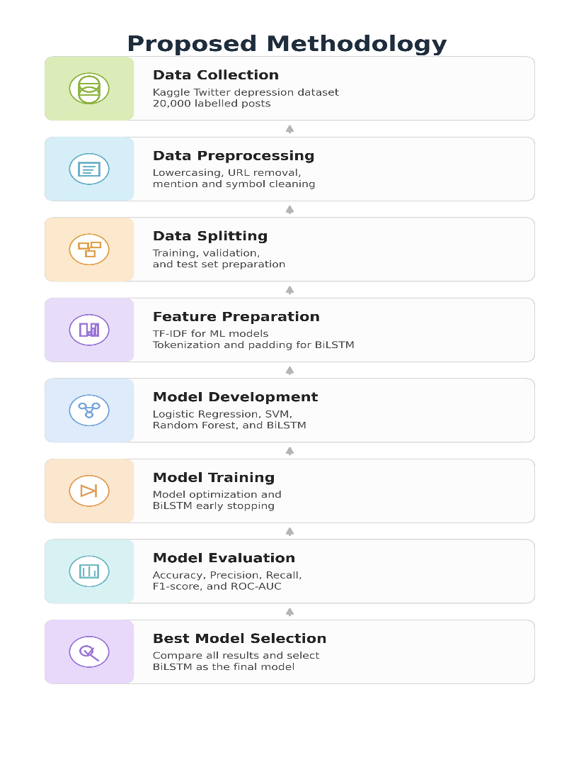

  - Research Design/ Prototype Design
The The project is designed as an experimental text classification framework consisting of the following main components:
- Twitter Dataset Collection
A labelled Kaggle Twitter depression dataset is used as the primary data source.
- Text Preprocessing
The tweets are cleaned by removing URLs, mentions, retweet tags, special characters, and extra spaces.
- Machine Learning Models
TF-IDF features are used to train Logistic Regression, SVM, and Random Forest classifiers.
- Deep Learning Model
A BiLSTM model is developed using tokenization and sequence padding for sequence-based classification.
- Comparative Evaluation
All models are evaluated using Accuracy, Precision, Recall, F1-score, confusion matrix, and ROC-AUC.
The final prototype output is a system that predicts whether a given Twitter text is Depressed or Not Depressed.

  - Data Collection/ Need Assessment
The dataset used in this phase was the Kaggle dataset “Depression: Twitter Dataset + Feature Extraction”, containing 20,000 labeled English tweets. After initial inspection, the project retained the main text column and class label. Text cleaning steps included lowercasing, removal of URLs, mentions, retweet tags, non-alphabetic symbols, and extra spaces. The data was then split into training, validation, and test subsets. This dataset was selected because it is sufficiently large, labeled, and directly aligned with the project objective.

  - Analysis Techniques
The analysis and experimentation of the dataset were carried out using both machine learning and deep learning techniques. For the traditional machine learning part, TF-IDF vectorization was applied to the cleaned tweet texts in order to convert them into numerical feature representations. Based on these features, Logistic Regression, Support Vector Machine (SVM), and Random Forest classifiers were trained and evaluated for depression-related text classification.
For the deep learning part, tokenization and sequence padding were used to prepare the tweet texts for a BiLSTM model. This sequence-based architecture was selected because it can capture contextual and sequential information from text more effectively than traditional feature-based methods. The dataset was divided into training, validation, and testing subsets to ensure proper evaluation and to monitor model generalization during training.
During model development, standard evaluation metrics such as Accuracy, Precision, Recall, F1-score, confusion matrix, and ROC-AUC were used to compare the performance of all implemented models. In the case of BiLSTM, early stopping and learning-rate reduction were applied to reduce overfitting and preserve the best model weights. Based on the comparative analysis, the best-performing model was selected for continuation into the next phase of the project.

- Progress Achieved:

  - Completed Tasks
The following tasks were completed during the reporting period:
1. Finalized the project topic and problem formulation.
2. Collected and inspected a labeled Twitter depression dataset.
3. Completed text preprocessing and data cleaning.
4. Performed exploratory data analysis and generated relevant graphs.
5. Developed and tested three machine learning models: Logistic Regression, SVM, and Random Forest.
6. Developed and evaluated a BiLSTM deep learning model.
7. Generated confusion matrices, comparison tables, and ROC-AUC curves for all models.

  - Results Obtained
The preliminary results indicate that the BiLSTM model achieved the best overall performance among all implemented models. As shown in Table 1, BiLSTM obtained the highest Accuracy (0.77625), F1-score (0.77753), and ROC-AUC (0.865). Logistic Regression and SVM also produced competitive results, while Random Forest showed comparatively lower overall performance despite achieving a relatively higher recall. Therefore, BiLSTM was selected as the most suitable model for the next phase of the project.
Table 1: Performance Comparison of Implemented Models
Model | Accuracy | Precision | Recall | F1-Score | ROC-AUC
Logistic Regression | 0.76075 | 0.74564 | 0.79150 | 0.76789 | 0.856
SVM | 0.76000 | 0.75540 | 0.76900 | 0.76214 | 0.851
Random Forest | 0.73700 | 0.70771 | 0.80750 | 0.75432 | 0.826
BiLSTM | 0.77625 | 0.77311 | 0.78200 | 0.77753 | 0.865

- Challenges Faced:
S.No. | Issues and Challenges | Strategies or Plans
1 | Noisy and weakly aligned labels in the dataset. | Used comparative evaluation across multiple models and relied on F1-score and ROC-AUC instead of accuracy alone.
2 | Short and context-poor tweets caused unstable predictions. | Applied text cleaning, sequence modeling, and error analysis to understand model behavior.
3 | BiLSTM training showed overfitting after early epochs. | Used early stopping and learning-rate reduction to preserve the best weights.
4 | Manual demonstration sentences sometimes produced inconsistent outputs. | Focused on evaluation metrics and real test-set performance rather than relying only on handcrafted examples.
5 | Slow training on CPU | Switched to GPU
6 | Large dataset handling | Optimized batch size and pipeline

- Next Steps:
S.No. | Next Task | Estimated completion time (MM-YY)
1 | Complete final literature review and improve Chapter 2. | 04-26
2 | Refine methodology, results, and discussion chapters. | 04-26
3 | Prepare presentation slides and defense materials for the next phase. | 04-26
4 | Build a simple demonstration interface and finalize the thesis draft. | 05-26

- Updated Timeline:
The updated timeline for the remaining work is summarized below:
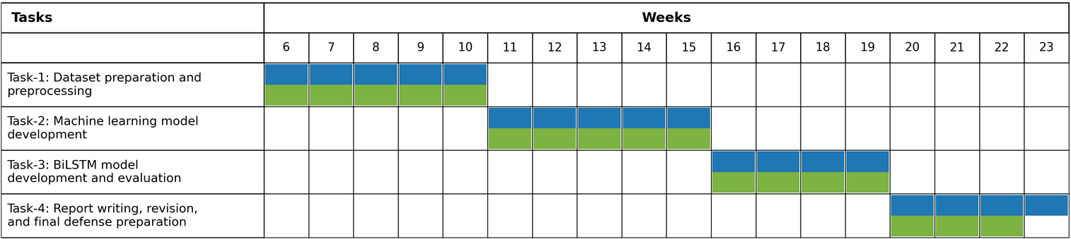
Estimated Work Period
Actual Work Period

- Resources Utilized:
The main resources utilized during this phase were a laptop computer with internet connection, Google Colab for cloud-based model execution, the Kaggle dataset for experimentation, and software libraries including Python, Pandas, NumPy, Scikit-learn, TensorFlow/Keras, Matplotlib, Seaborn, and NLTK.

- Project Management and Financial Analysis:
S.No. | Component | Description | Cost
1 | Internet Cost | Data usage for literature review, dataset download, model training, and report preparation | ৳500/month
2 | Google Colab | Cloud-based notebook environment for model training and experimentation | ৳0
3 | Electricity Cost | Laptop usage for coding, training, testing, and documentation | ৳300/month
4 | Dataset Source | Kaggle Twitter depression dataset used for experimentation | ৳0
5 | Software Tools | Python, Pandas, NumPy, Scikit-learn, TensorFlow/Keras, Matplotlib, Seaborn, NLTK | ৳0
6 | Storage | Google Drive / local storage for dataset and result files | ৳0
7 | Hardware | Personal laptop used for implementation and report writing | Existing
8 | Printing and Documentation | Printing draft report, presentation materials, and related documents | ৳300 (one-time)

Total Estimated Cost
- One-time Cost ≈ ৳300
- Monthly Cost ≈ ৳800
The project was managed in a structured sequence of phases, including topic selection, background study, dataset collection, preprocessing, machine learning model development, deep learning model development, evaluation, and report preparation. Since the work is based mainly on a publicly available Twitter depression dataset and open-source software tools, the financial cost of the project remained minimal during Phase-I. The principal recurring costs were internet usage for literature review, dataset download, cloud-based experimentation, and electricity required for laptop-based coding and documentation. Because the dataset was collected from Kaggle and tools such as Google Colab, Python, Scikit-learn, TensorFlow/Keras, and other libraries were freely available, no major implementation cost was involved. Only a small one-time expense may be considered for printing and documentation purposes. Therefore, the project can be considered cost-effective, practical, and economically feasible for student-level thesis research.
- Future Considerations:
In next phase, attention will be given to improving model robustness, refining the literature review, preparing a full thesis manuscript, and building a clearer demonstration interface for prediction. Since the dataset may contain noisy labels and short-context text, future work will also consider better preprocessing strategies, additional model tuning, and more detailed error analysis.
- Conclusion:
This Phase-I work successfully established a complete AI-based framework for depression-related text classification using Twitter data. The project covered the major tasks required at this stage, including dataset preparation, text preprocessing, exploratory analysis, feature preparation, machine learning model development, deep learning model development, and comparative performance evaluation. As a result, a clear and reproducible baseline pipeline has been developed for identifying depression-related signals from short social media text.
The experimental findings show that all implemented models were able to perform the binary classification task with reasonable effectiveness. Among them, the BiLSTM model achieved the best overall performance in terms of Accuracy, F1-score, and ROC-AUC, and therefore it has been selected as the primary model for further refinement in the final phase of the thesis. This result indicates that sequence-based deep learning can provide a better balance of performance for noisy and context-limited Twitter data than the implemented baseline machine learning models.
Overall, the progress achieved in Phase-I is satisfactory and provides a strong foundation for the next stage of the project. In the final phase, the work will focus on refining the report, improving discussion and analysis, and strengthening the presentation of results. Therefore, the current phase has successfully met its main objectives and prepared a solid basis for final thesis completion.
References
[1] J. Cha, S. Kim, and E. Park, “A lexicon-based approach to examine depression detection in social media: The case of Twitter and university community,” Humanities and Social Sciences Communications, vol. 9, art. no. 325, 2022.
[2] R. Poświata and M. Perełkiewicz, “OPI@LT-EDI-ACL2022: Detecting signs of depression from social media text using RoBERTa pre-trained language models,” in Proc. 2nd Workshop on Language Technology for Equality, Diversity and Inclusion, 2022, pp. 276–282.
[3] M. A. Al-Garadi, Y.-C. Yang, S. Lakamana, et al., “Depression detection on social media: A classification framework and research challenges and opportunities,” Journal of Healthcare Informatics Research, 2023.
[4] D. S. Khafaga, M. Auvdaiappan, K. Deepa, M. Abouhawwash, and F. K. Karim, “Deep learning for depression detection using Twitter data,” Intelligent Automation & Soft Computing, vol. 36, no. 2, pp. 1301–1313, 2023.
[5] M. Kanahuati-Ceballos and L. J. Valdivia, “Detection of depressive comments on social media using RNN, LSTM, and random forest: Comparison and optimization,” Social Network Analysis and Mining, vol. 14, art. no. 44, 2024.
[6] P. Ta, N. Tran, H. Nguyen, and H. D. Nguyen, “Detecting signs of depression on social media: A machine learning analysis and evaluation,” Sustainable Futures, vol. 10, art. no. 100827, 2025.
[7] World Health Organization, “Depressive disorder (depression),” Fact sheet, 2025.

Appendix
Appendix 1: Sample dataset snapshot
 | post_text | label
0 | It's just over 2 years since I was diagnosed w... | 1
1 | It's Sunday, I need a break, so I'm planning t... | 1
2 | Awake but tired. I need to sleep but my brain ... | 1
3 | RT @SewHQ: #Retro bears make perfect gifts and... | 1
4 | It’s hard to say whether packing lists are mak... | 1
Appendix 2: Sample Preprocessed Text
post_text | cleaned_text
It's just over 2 years since I was diagnosed w... | it s just over years since i was diagnosed wit...
It's Sunday, I need a break, so I'm planning t... | it s sunday i need a break so i m planning to ...
Awake but tired. I need to sleep but my brain ... | awake but tired i need to sleep but my brain h...
RT @SewHQ: #Retro bears make perfect gifts and... | retro bears make perfect gifts and are great f...
It’s hard to say whether packing lists are mak... | it s hard to say whether packing lists are mak...

Appendix 3: Distribution of text Length
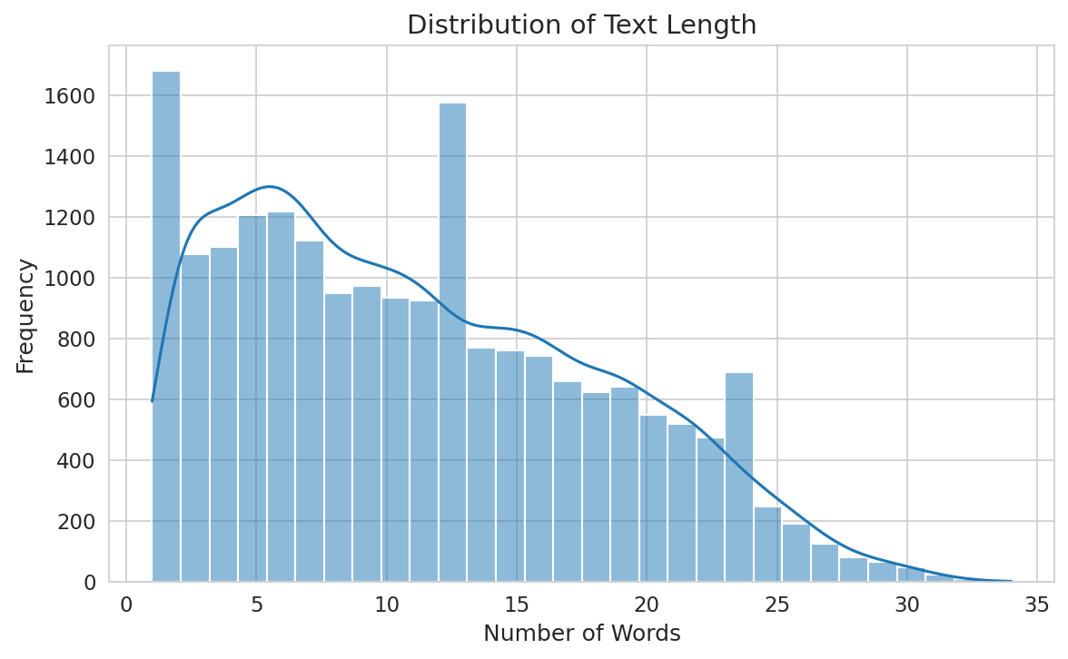
Appendix 4: Performance comparison of all models
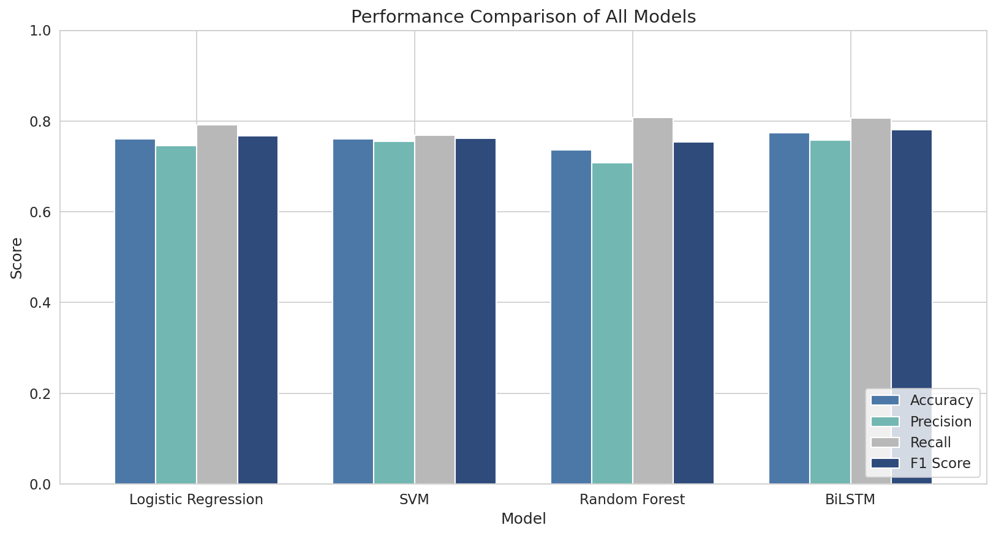

Appendix 5: Confusion matrices of all models
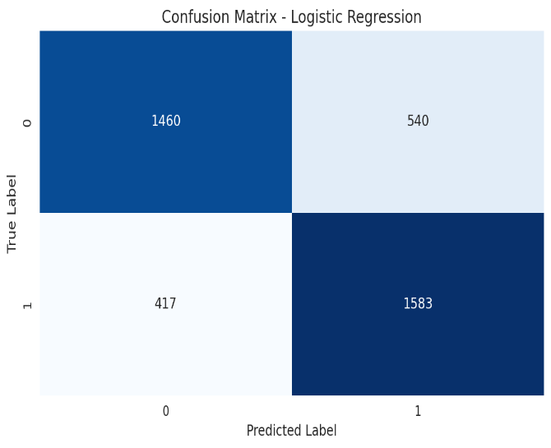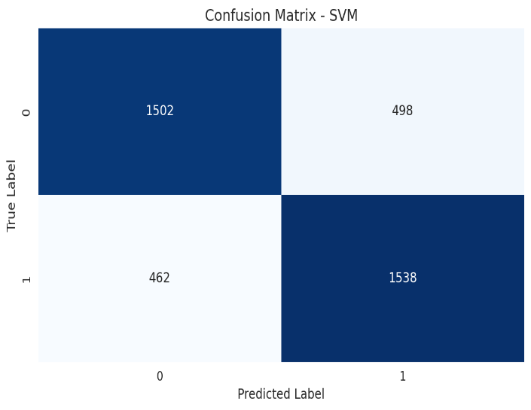
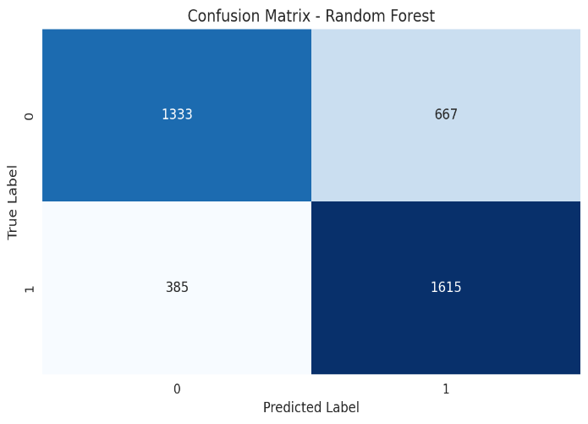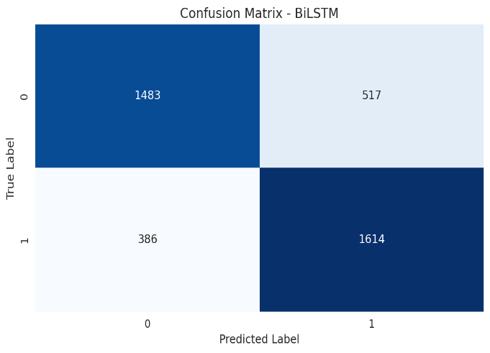
Appendix 6: ROC-AUC Curve
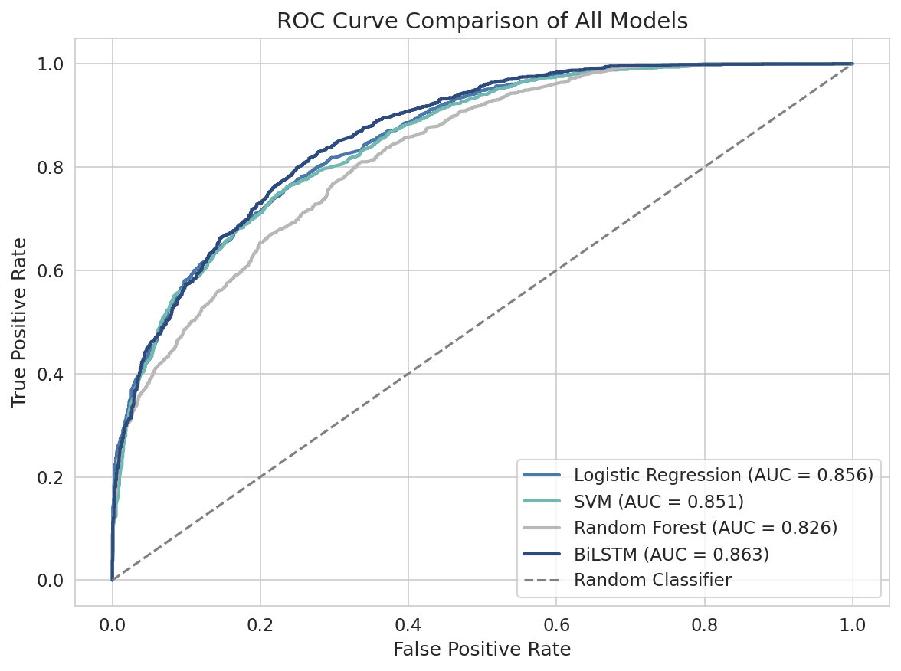
Appendix 7: BiLSTM training curve
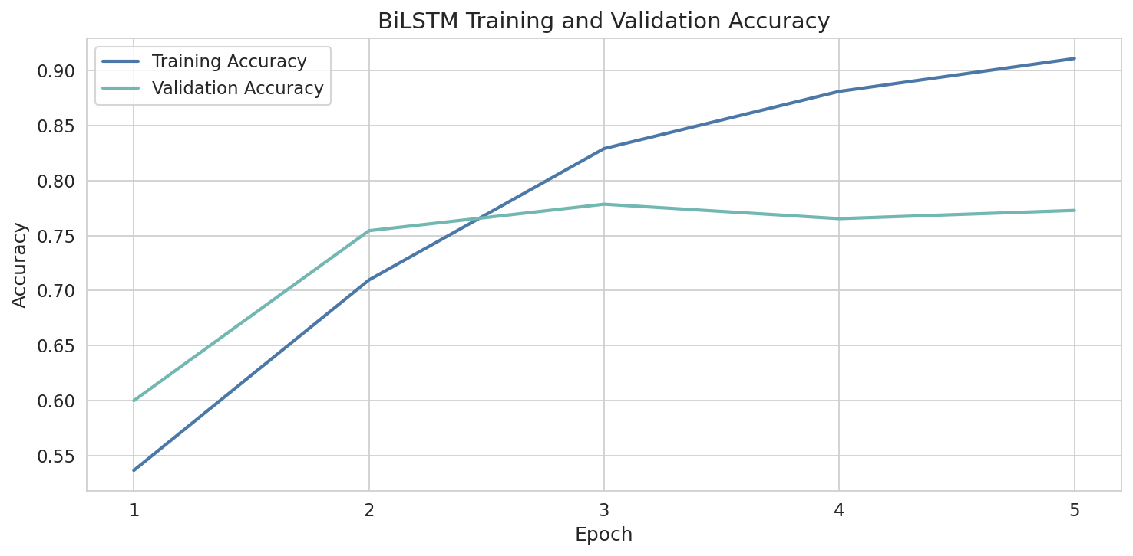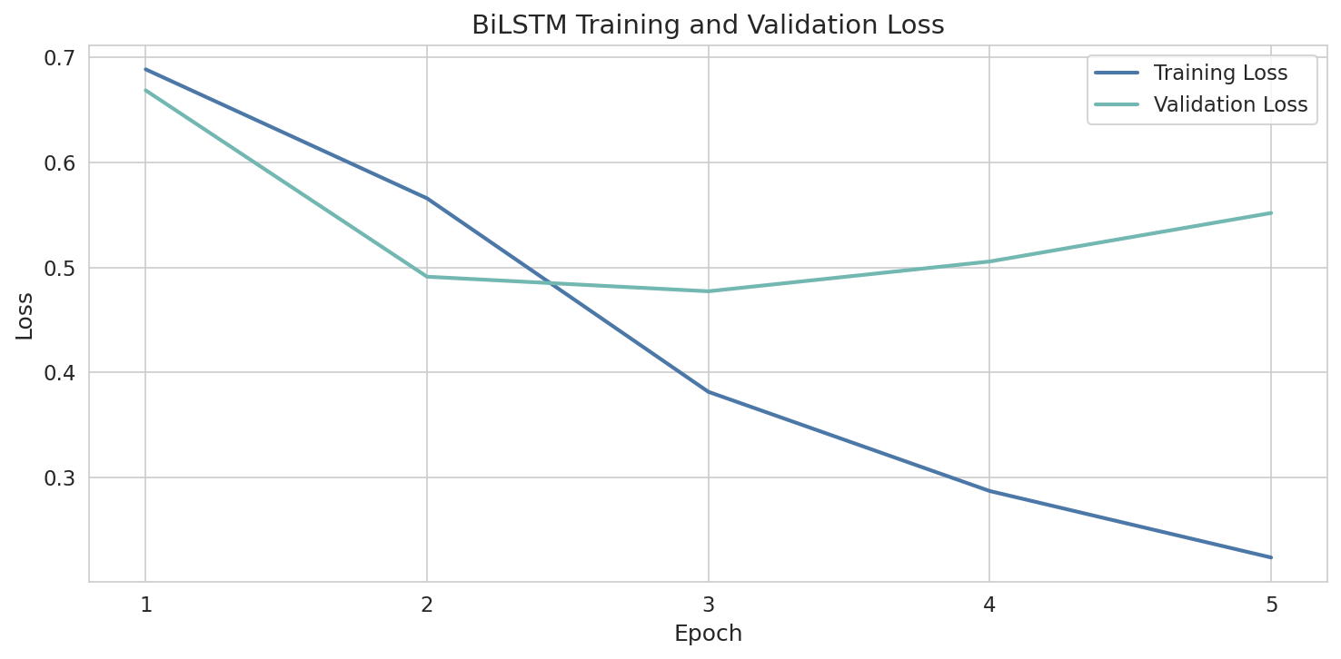
Appendix 8: Example Predictions
 | Input Sentence | Prediction Score | Predicted Class
0 | I hate myself and I feel hopeless every day. | 0.928096 | Depressed
1 | Nothing feels worth it anymore. | 0.928985 | Depressed
2 | I feel tired, broken, and lost all the time. | 0.919250 | Depressed

